LoRA (Low-Rank Adaptation) models are a type of machine learning model often used to fine-tune pre-trained models efficiently. In this case, the LoRA models described in example.py were trained with the following details:

* **Training Duration**: The models were trained for approximately 2 hours.
* **Hardware Used**: The training was conducted on a NVIDIA 3080Ti GPU with 12 GB of VRAM.
* **Resource Consumption**:
  + **VRAM Usage**: The training process consumed 5.66 GB of the available 12 GB VRAM.
  + **RAM Usage**: Approximately 4 GB of system RAM was utilized during the training.
* **Convergence**: The model reached a similar state of convergence in less than 30 minutes, even though the total training duration was around 2 hours.

**Explanation**

1. **Training Duration and Hardware**:
   * The NVIDIA 3080Ti is a high-performance GPU with 12 GB of VRAM, suitable for demanding tasks like training machine learning models.
   * The training process took around 2 hours, which indicates the model was likely fine-tuning a pre-trained network using the LoRA technique.
2. **Resource Consumption**:
   * **VRAM**: 5.66 GB of VRAM usage suggests that the model and its associated data fit well within the GPU's memory, allowing efficient computation without excessive swapping or memory bottlenecks.
   * **RAM**: The use of 4 GB of system RAM indicates that some parts of the data or model parameters were stored in system memory, complementing the VRAM usage.
3. **Convergence**:
   * The model converging to a similar state in less than 30 minutes implies that the bulk of the learning occurred early in the training process. This is common in fine-tuning scenarios where a pre-trained model is already close to the desired solution, and only minor adjustments are needed.
   * The remaining training time likely involved refining the model's parameters to achieve optimal performance, reducing any residual errors or overfitting.

In summary, the described LoRA model training was efficient, utilizing a 3080Ti GPU's capabilities well. Despite the total training time being 2 hours, the model achieved most of its learning early on, demonstrating the effectiveness of the fine-tuning process.

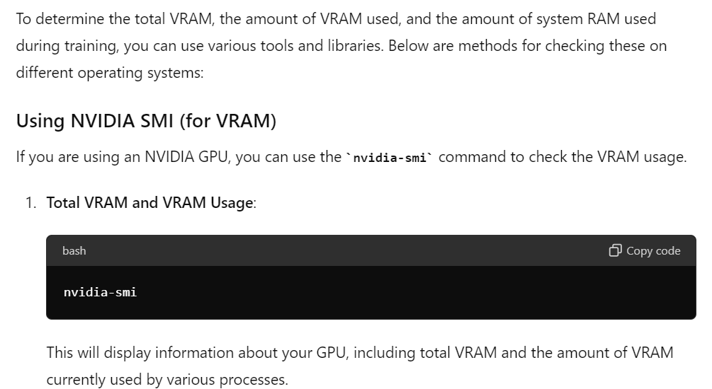

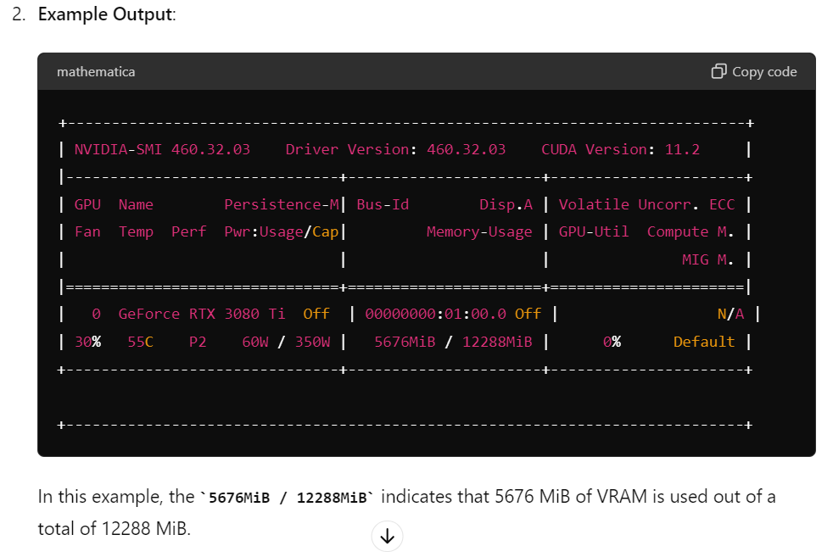

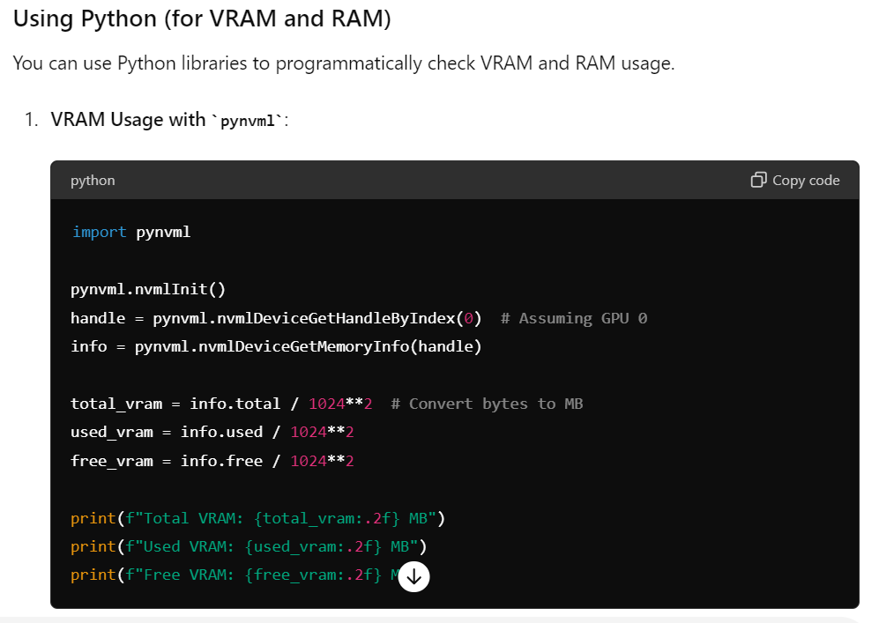

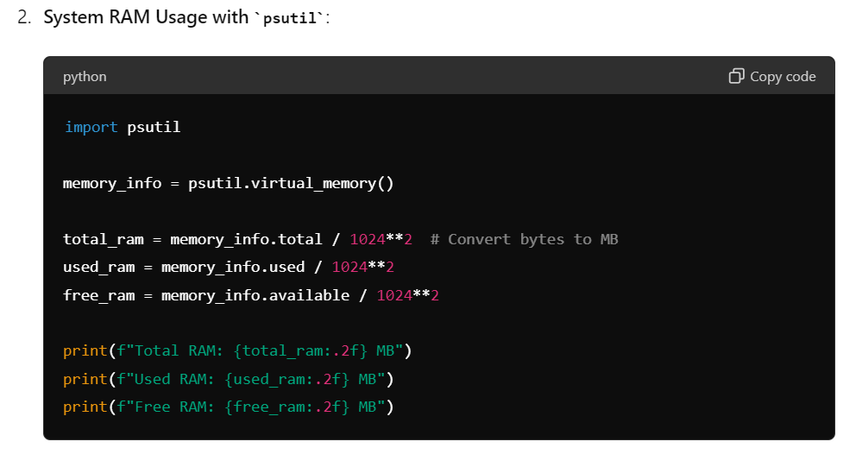

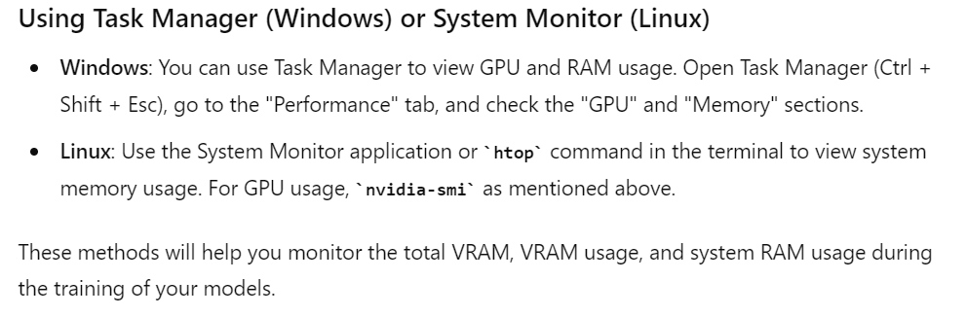

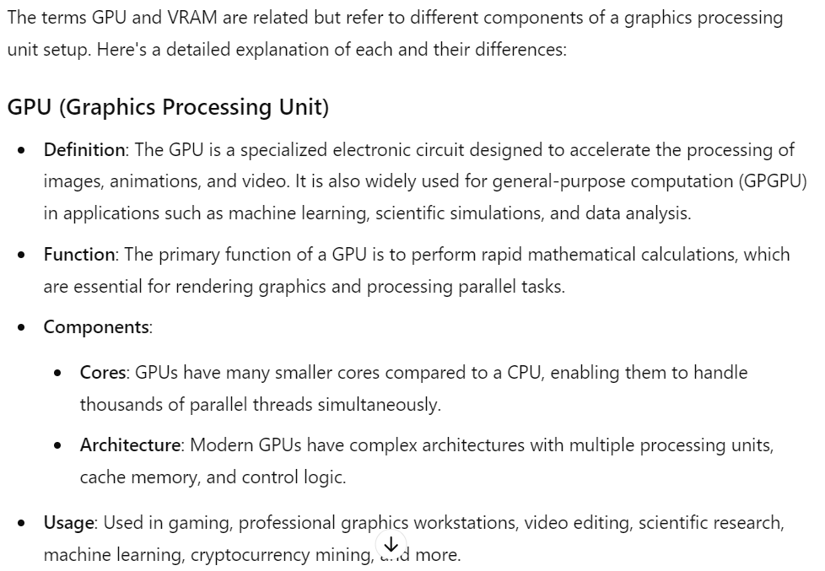

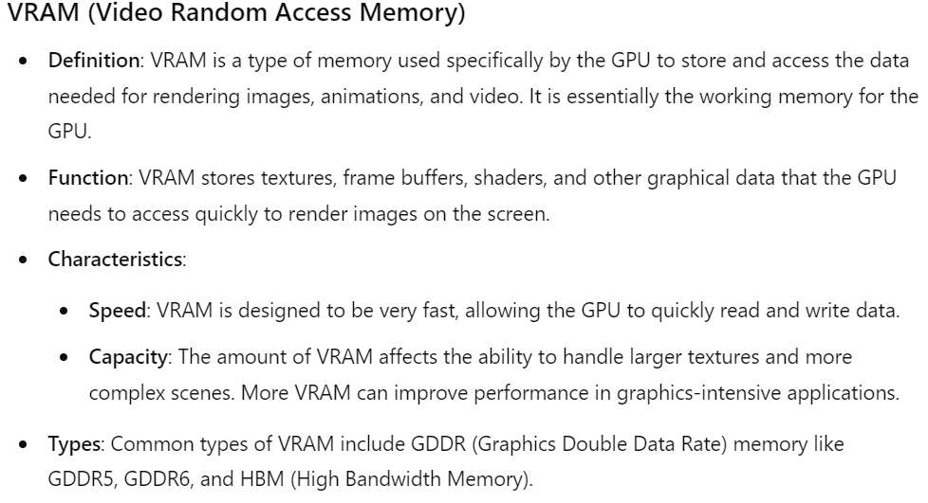

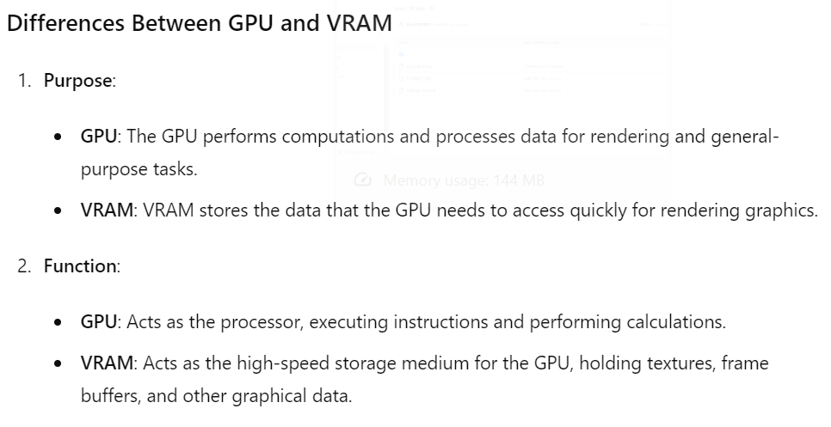

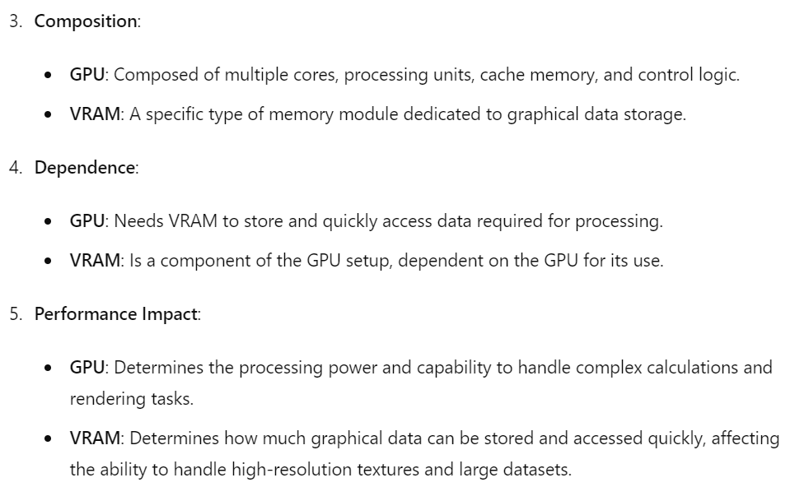

In summary, the GPU is the processing powerhouse responsible for rendering and computation, while VRAM is the high-speed memory that stores the data the GPU needs to access quickly to perform its tasks efficiently. Both are essential for high-performance graphics and computational applications, but they serve different roles in the system.

import pynvml

pynvml.nvmlInit()

handle = pynvml.nvmlDeviceGetHandleByIndex(0) # Assuming GPU 0

info = pynvml.nvmlDeviceGetMemoryInfo(handle)

total_vram = info.total / 1024**2 # Convert bytes to MB

used_vram = info.used / 1024**2

free_vram = info.free / 1024**2

print(f"Total VRAM: {total_vram:.2f} MB")

print(f"Used VRAM: {used_vram:.2f} MB")

print(f"Free VRAM: {free_vram:.2f} MB")

import psutil

memory_info = psutil.virtual_memory()

total_ram = memory_info.total / 1024**2 # Convert bytes to MB

used_ram = memory_info.used / 1024**2

free_ram = memory_info.available / 1024**2

print(f"Total RAM: {total_ram:.2f} MB")

print(f"Used RAM: {used_ram:.2f} MB")

print(f"Free RAM: {free_ram:.2f} MB")